Matlab AUV Workbench
User Manual

by

Sean Kragelund, 20 May 2004

Revised Don Brutzman & Ken Teo, 3 November 2003

The Matlab AUV Workbench is a Simulink-based AUV simulator which allows engineers to develop, test, and simulate control algorithms for the NPS Phoenix and Aries AUVs. Simulation results are displayed in the form of Matlab 2D plots and/or VRML 3D visualization. Current Simulink models can either simulate AUV station-keeping with sliding mode control or open-loop actuator commands. All models subject the AUV to simulated wave action.

Before using the workbench, first edit the classpath.txt file in <MatlabRoot>/toolbox/local to include the lines:

C:\auv\MatlabSimulator\matlab
C:\auv\MatlabSimulator\vrml\dis-java-vrml.jar

If Matlab is running, exit the program. Next double-click the Launch.bat file in the MatlabSimulator directory to start the simulator. Matlab will begin running and the following GUI will appear:

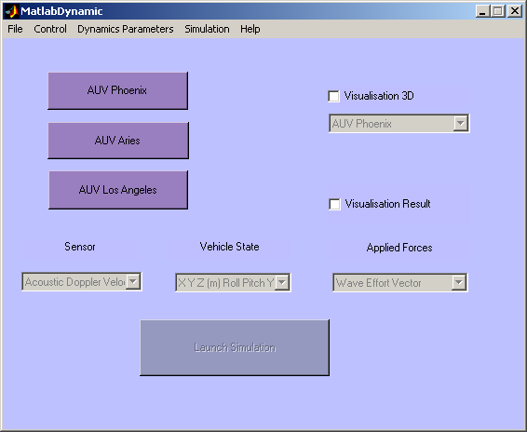
1
To perform a simulation:

- First, select the type of AUV to simulate. This will load the vehicle model and initial simulation parameters into the Matlab workspace.

Note: The “AUV Los Angeles” vehicle model has not been tested and/or verified.

- Next, use the menu to select individual simulation parameters as shown.

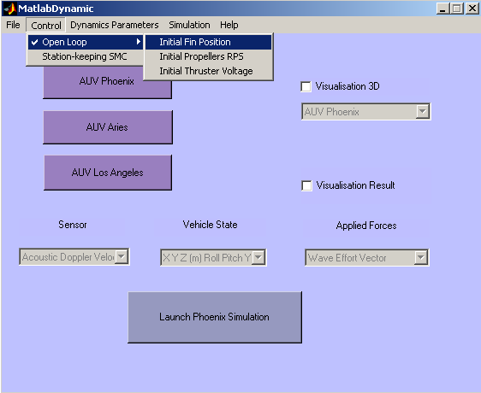
2
3
4
5

The menu options are described as follows:

File
Open Retrieve saved workspace data (or open any Matlab file).
Save Save current workspace to a Matlab .mat file.
Close Exit the simulator.

Control
Open Loop The following options allow you to specify the
Initial Fin Position fin position,
Initial Propellers RPS propeller speed, and
Initial Thruster Voltage thruster voltage for the open loop simulation.
Station-keeping SMC Specifies a sliding mode controller for closed loop station-
keeping.
Dynamics Parameters
Read dynamics coefficients Creates coefficients.txt to display the current coefficients.
Modify dynamics coefficients Opens a series of dialog boxes for modifying dynamics
Coefficients and simulation parameters (see below).
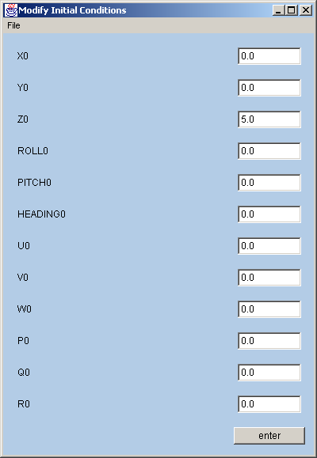
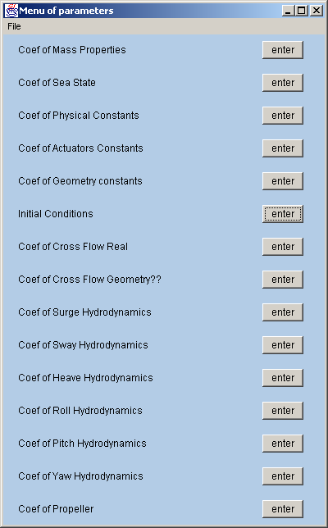

Note: The “Coef of Cross Flow Geometry??” option is undefined and causes a non-fatal error.
Simulation
Edit Model Opens the Simulink model for the current simulation settings.
New equations of motion Currently undefined.

Help
Documentation Opens the HTML documentation for the original simulator.
Matlab help Opens the HTML Matlab help documentation.

- For a 3D graphical animation of the simulation select the “Visualisation 3D” check box, then select either “AUV Phoenix” or “AUV Aries” from the corresponding pull-down menu. A web browser will open containing the VRML scene for the chosen scenario.

- To enable 2D plotting of simulation results select the “Visualisation Result” check box. Notice that the Sensor, Vehicle State, and Applied Forces pull-down menus are now active. After a simulation, select the desired output data from these menus to generate a plot.

- Select the “Launch ___ Simulation” button to run the Simulink simulation.

While most simulator functions can be accessed through the GUI, the real power of this tool is the ability to create or modify Simulink models to test different sensors, controllers, etc. The Simulink models use precompiled s-functions written in C to improve simulation performance and connect simulation outputs to VRML inputs. Refer to the Matlab/Simulink online help for information on subsystem masking and s-function usage.

Note: For the closed loop station-keeping SMC controller, desired vehicle state must be manually entered into the Simulink model by opening the Control/Thrusters/SurgeSwayYaw Control block and filling the desired state vector.

